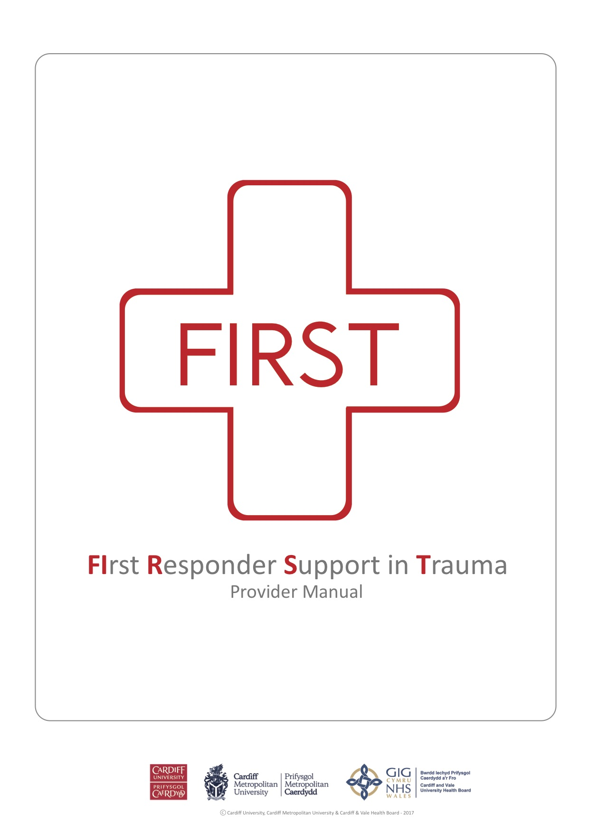

Train The Trainers Manual
First Responder Support in Trauma (FiRST) Train the Trainer Course
Using the Cardiff Trauma Pack

Aims

- Improve upon the knowledge and skills obtained during the FiRST Provider Course and develop a more advanced understanding of the management of major trauma
- Discuss basic educational theory and the principles of adult learning
- Learn how to deal with problems and issues that may arise during a training session
- Learn how to provide constructive feedback
- Learn how to facilitate simulated scenarios using role-play
- Learn strategies for running a successful teaching session or course
- Develop skills to maintain candidate’s interest and enthusiasm

Education Theory

What do you students want?
What do you want them to go away with?

Knowledge Skills Confidence

How do you give these to them?
You need to make sure that your teaching is:

Interesting Entertaining Relevant

Also, most importantly, make sure you address their BASIC NEEDS before anything else
i.e. comfort, food, drink, rest, etc.

Your students will be wondering why they need to be here?
Why do they need to do this?

Tell them the problem that needs to be solved

Make sure they realise that they are a part of the solution

What do you need to know in order to achieve this?

How adults learn

How to keep them engaged and interested

How to deal with problems

How to answer questions

How to run a demonstration

How to run a scenario

How to answer questions

How to keep to time

How to assess their ability

Much of the time, the success of your teaching session depends on your ability to

Improvise & Adapt

Adult Learning

Adult learning is affected by:

- Previous life experiences
- Pre-conceived ideas
- Varying levels of knowledge
- Varying levels of experience

Adults may potentially have a very fixed view on things. You need to be prepared to challenge those views in positive and supportive way and open their mind.

Learning must be directly relevant to them and must be centered around a specific problem

Adults learn best when they can immediately apply what they have learned.
The FiRST Responder Course is built around this idea:

Not very much will be remembered
Talk at someone for an entire day

Get someone to practice what they are learning
Much more likely to be remembered

Continuous learning comes from activity

How to maintain an adult learner’s interest:

Tell stories

Use student’s own experiences

Use personal anecdotes and experiences

Challenge assumptions

Use humour

Make it relevant to them

Continually emphasise the importance

Dealing with problems while teaching

During the course we discussed all the potential problems we could think of that could come up during teaching.

The first step in being able to address some of these problems is to recognize that they might happen. Then you can start to work out your own strategies for managing them.

Potential Problems:

- Lack of interest, Boredom
- Quiet, shy, nervous students. Feelings of inferiority.
- Stubborn students
- Distractions – Other students, different groups, Phones
- Very enthusiastic students dominating the teaching session, asking lots of questions, not giving other students a chance to speak or engage
- Know-it-alls, students who think they already know the material better than you!
- Time-keeping
- Misunderstanding, confusion: students not understanding what you are trying to teach them
- Upsetting students
- Affecting student’s confidence
- Reinforcing poor technique or inappropriate behaviour
- Dealing with student’s who have a lack of willingness to accept criticism or act defensive
- Inappropriate focus on minor details or irrelevant issues, not focusing on the key messages.
- Answering difficult (or impossible!) questions. Inability to explain things clearly.
- Communication issues – language difficulties
- Manging the issue of ranks & hierarchy
- Lack of command & control
- Managing expectations

Giving feedback

To be effective, feedback needs to be CONSTRUCTIVE

The aim of feedback is to provide ENCOURAGEMENT and build CONFIDENCE

Reinforce Positives

Don’t “nit-pick” on every little mistake
Provide REFLECTION rather than DIRECTION
Bad Practice
Good Practice
Avoid relentless optimism

  - Tips & Tricks for Feedback

- Try to involve everyone in the group in the feedback
- Use open-ended questions:
  - How did you feel about that scenario?
  - So…that was a tough one wasn’t it?....
  - What did you think of that situation?
- Avoid closed questions and leading questions:
  - Why do you think you forgot to put the pelvic binder on?
  - Did you think you did a good job getting the patient out of the car safely?
- Pose questions to explore candidate’s thinking behind what they did or did not do
- You need to be genuinely curious about what they have to say when you pose a question
- Avoid listing all the things they did right or did wrong
- Emphasise the positives more than the negatives wherever possible

It is incredibly important to listen carefully to the student and their responses during feedback

Try to work out what is bothering them the most

Running a scenario

  - Tips & Tricks for running scenarios

- Take the time to ensure your station is properly setup:
  - Do you have all the kit you need? Is it laid out appropriately?
  - Do you need any other teaching aids – paper, airway heads, etc.
- Lead by example – get stuck in with role-playing and acting as the patient. Makes teaching much more memorable (and fun!). Candidates much more likely to follow your lead.
- Safety – look after yourself and each other, particularly when using equipment that can potentially hurt (e.g. rubber bandage) and when moving candidates as patients. You are responsible for the safety of your group.
- Remember you need to have the ability to improvise and adapt depending on how the scenario is progressing
- Try to keep each scenario as short as possible (but long enough to get the key messages across) otherwise other members of the group may get bored and you will struggle to keep to time and get through enough scenarios.
- Make sure you finish the scenario in the right way.
  - Make it clear that you’ve stopped.
  - Try to make what you say and the way you say it fairly neutral.
  - Sometimes you can be a bit more positive with how you finish a scenario but never be negative! (i.e. exasperated, clearly unimpressed, etc.)

The scenario itself an important element of the teaching but never forget the importance of

Debriefing & Feedback

Running a scenario as an assesment

- When assessing a candidate, the scenario runs in a very similar way to a teaching scenario but with a few important differences:
  - You need to make it clear that this a scenario to assess “the standard they have reached” before they start
  - The trainer needs to have a more “hands-off” approach with less guidance as there would be in a teaching scenario
  - Try to maintain a neutral expression/appearance throughout regardless of how well or poorly a candidate is doing
  - It is even more important to finish the scenario in a neutral way
  - Don’t give feedback on how they did straight away:
    - It is far better to tell them about it afterwards as you may want to discuss something privately with another trainer or the course director before coming to a final decision.
  - Avoid using the word “FAIL”:
    - When you do talk to them about their performance, say something along the lines of “you haven’t quite been able to demonstrate the standard we would expect”. But make it clear to them there is the opportunity for further training and to “have a chance to demonstrate this later” (i.e. a repeat assessment)

Running a successful teaching session/course

- Planning
  - Take the time to plan out what you are going to do throughout the teaching.
- Logistics
  - Think about the best layout for the groups – is there enough space? Are there the chairs, tables, etc that you will need
  - Check your kit! You are responsible for making sure you have the kit you need for training
  - Take the time to get as much stuff set up before you start. Don’t assume you will have the time during breaks/changeover of groups.
- Basic needs
  - Regular breaks
  - Refreshments, Lunch (if full day course)
  - Comfortable environment
  - Temperature – too hot, too cold
- Keeping to time
  - One of the most challenging issues with teaching is trying to keep to time
  - Particularly difficult when you have different groups working at the same time
  - Your candidates will not appreciate it if you constantly overrun!
  - Keep an eye on the time, you may need to adapt:
    - Offer to address difficult questions or concerns from one individual at a later time (during a break, at the end of the course)
    - Prioritise – make sure you teach the key messages, sacrifice more minor teaching points if absolutely necessary
- The power of names
  - Use your student’s names! Very important to get them engaged with teaching
  - Make sure you introduce yourself to every new group
  - As a trainer you should always have your name badge clearly visible. Students will forget your name in the same way you forget theirs! Make it easy for them to remember without being embarrassed to ask.

